­­­Research data:

Finding homologs between sequences for chr8 700,001..795,000

Chr8 sequence Annotations

Annotation: chr8

PASTE CODING REGION HERE:­­



[chr8:49455025-49458016 - strand] [peptide]

IsoSeq Top Tier Results

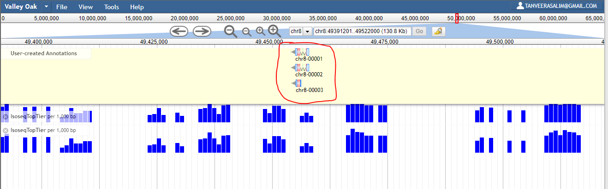

IsoSeq Top Tier Results Close-Up

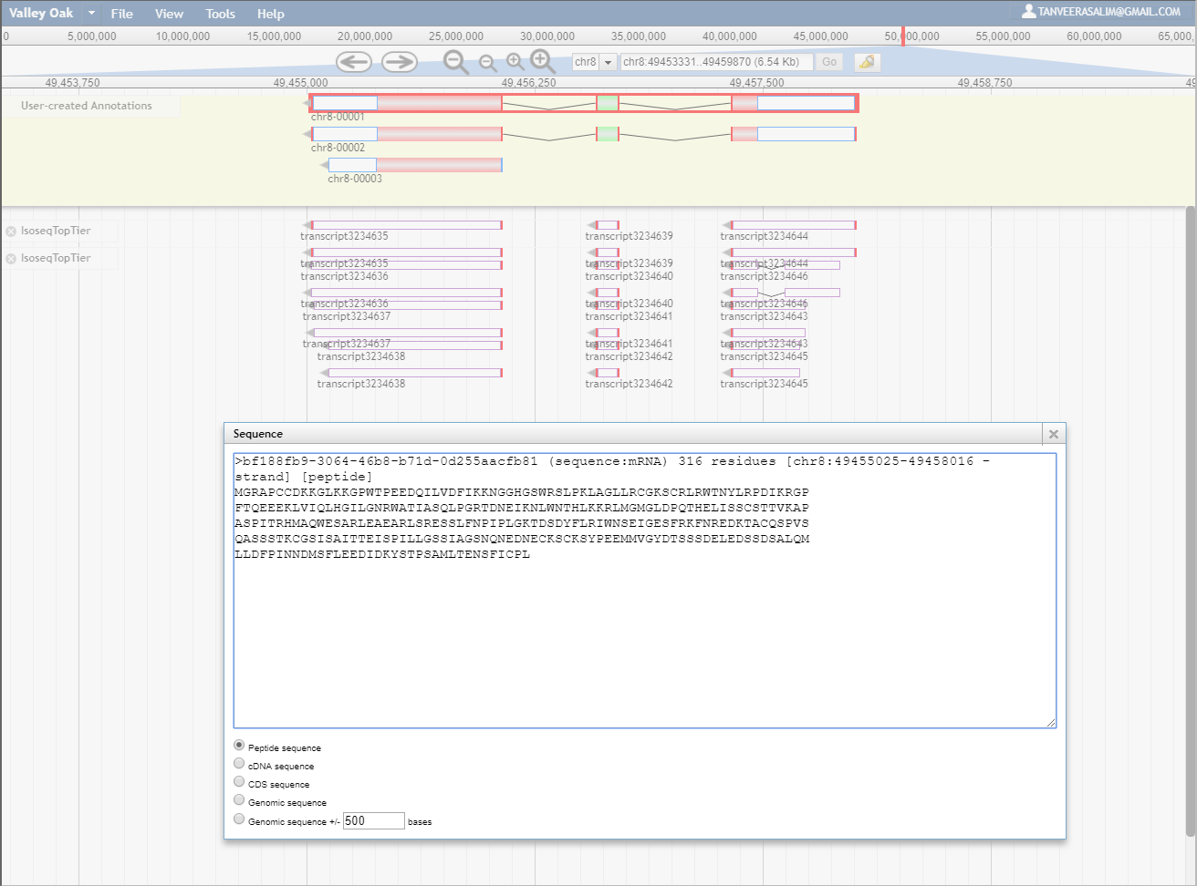

Peptide Sequences being Compared:

>bf188fb9-3064-46b8-b71d-0d255aacfb81 (sequence:mRNA) 316 residues [chr8:49455025-49458016 - strand] [peptide]

MGRAPCCDKKGLKKGPWTPEEDQILVDFIKKNGGHGSWRSLPKLAGLLRCGKSCRLRWTNYLRPDIKRGP

FTQEEEKLVIQLHGILGNRWATIASQLPGRTDNEIKNLWNTHLKKRLMGMGLDPQTHELISSCSTTVKAP

ASPITRHMAQWESARLEAEARLSRESSLFNPIPLGKTDSDYFLRIWNSEIGESFRKFNREDKTACQSPVS

QASSSTKCGSISAITTEISPILLGSSIAGSNQNEDNECKSCKSYPEEMMVGYDTSSSDELEDSSDSALQM

LLDFPINNDMSFLEEDIDKYSTPSAMLTENSFICPL

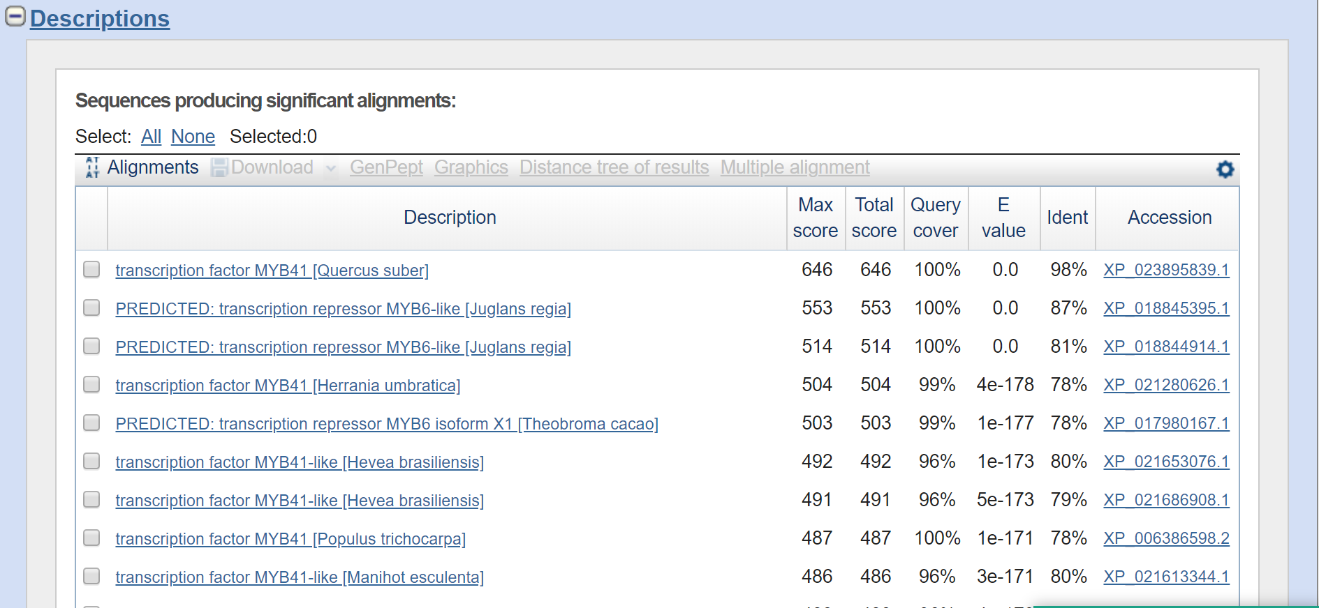

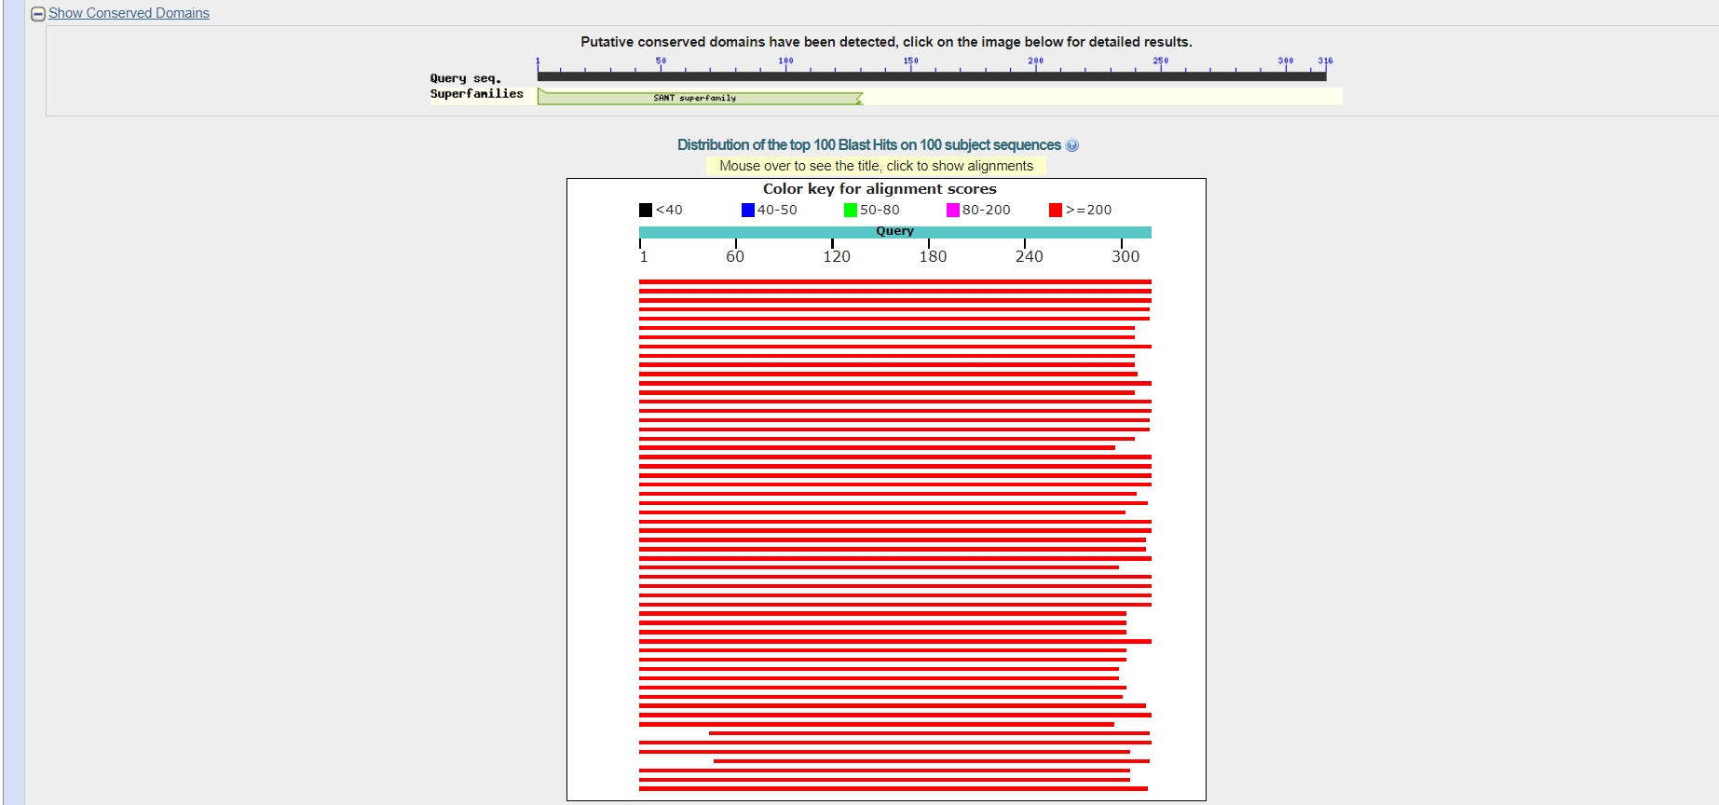

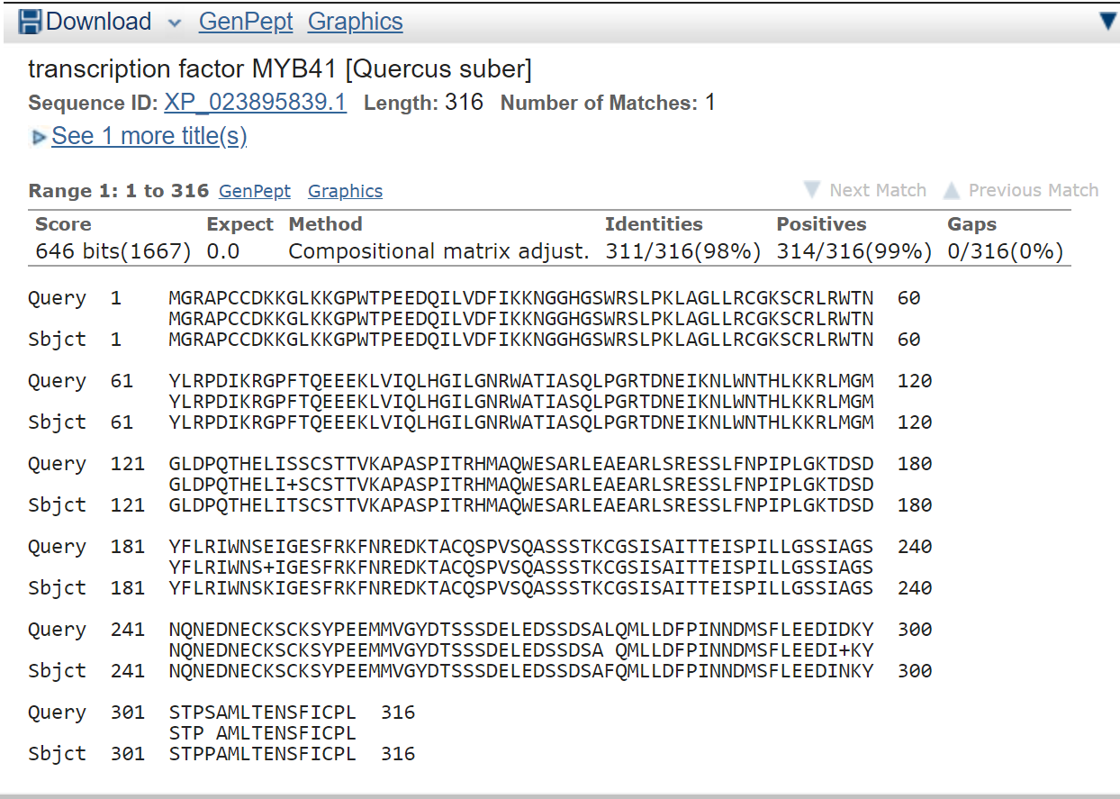

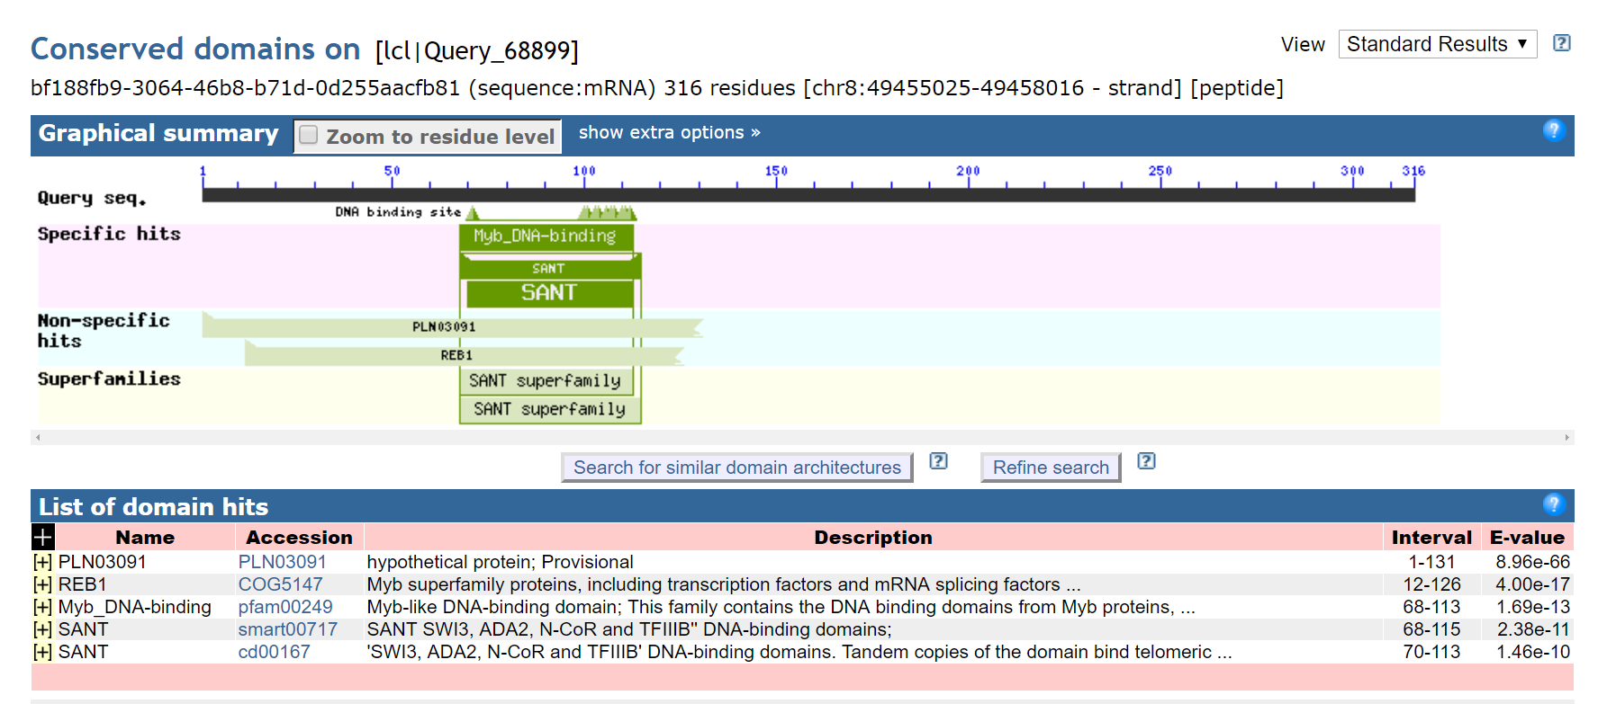

-----------------------------------------------------------------------------------------------------------------------------------

**transcription factor MYB41 [Quercus suber]**

**NCBI Reference Sequence: XP_023895839.1**

>XP_023895839.1 transcription factor MYB41 [Quercus suber]

MGRAPCCDKKGLKKGPWTPEEDQILVDFIKKNGGHGSWRSLPKLAGLLRCGKSCRLRWTNYLRPDIKRGP

FTQEEEKLVIQLHGILGNRWATIASQLPGRTDNEIKNLWNTHLKKRLMGMGLDPQTHELITSCSTTVKAP

ASPITRHMAQWESARLEAEARLSRESSLFNPIPLGKTDSDYFLRIWNSKIGESFRKFNREDKTACQSPVS

QASSSTKCGSISAITTEISPILLGSSIAGSNQNEDNECKSCKSYPEEMMVGYDTSSSDELEDSSDSAFQM

LLDFPINNDMSFLEEDINKYSTPPAMLTENSFICPL

# PREDICTED: transcription repressor MYB6-like [Juglans regia]

NCBI Reference Sequence: XP_018845395.1

>XP_018845395.1 PREDICTED: transcription repressor MYB6-like [Juglans regia]

MGRAPCCDKRGLKKGPWTPEEDEILVEYIKKNGGHGSWRSLPKLAGLLRCGKSCRLRWTNYLRPDIKRGP

FTQEEEKLVVQLHGILGNRWASIAAQLPGRTDNEIKNLWNTHLKKRLVCMGLDPQTHEPVNSCSTTIKAP

ASPTTRHMAQWESARLEAEARLSRESSLFHPNPVGGTDSDYFLRIWNSEVGESFRKFSMGDKTLCQSPVS

QASSSTKCGSMSAITTEICPILGGSSIAGSNQNEDTECKSCKSYTEEMMAASDCSSSDELEDSSENALQL

LLDFPINNDMSFLEEDLDMYALPPAMLTESSFICHL

# transcription factor MYB41 [Herrania umbratica]

NCBI Reference Sequence: XP_021280626.1

>XP_021280626.1 transcription factor MYB41 [Herrania umbratica]

MGRTPCCDRKGLKKGPWAPEEDEILVNYIKKHGHGSWRSLPKLAGLLRCGKSCRLRWTNYLRPDIKRGPF

TLEEEKLVIQLHGILGNRWAAIASQLPGRTDNEIKNLWNTHLKKRLVCMGLDPQTHEPFTPCGPTTAAPT

SPATRHMAQWESARLEAEARLSRESLLFSSPPLGKPDSDYFLRLWNSEVGESFRKLNREDKTACQSPISQ

ASSSTKCGSVSAVTIDICPNIAGSSTPASNQIEDTACKSFKSCTEDPVDASDSSCSNESEDSSDTALQLL

LDFPINNDMSFLENVDAYATSAAMLTDTSFISPSEGYLKA

# PREDICTED: transcription repressor MYB6 isoform X1 [Theobroma cacao]

NCBI Reference Sequence: XP_017980167.1

[GenPept](https://www.ncbi.nlm.nih.gov/protein/XP_017980167.1?report=genpept) [Identical Proteins](https://www.ncbi.nlm.nih.gov/ipg/XP_017980167.1) [Graphics](https://www.ncbi.nlm.nih.gov/protein/XP_017980167.1?report=graph)

>XP_017980167.1 PREDICTED: transcription repressor MYB6 isoform X1 [Theobroma cacao]

MGRTPCCDRKGLKKGPWAPEEDEILVNYIKKHGHGSWRSLPKLAGLLRCGKSCRLRWTNYLRPDIKRGPF

TLEEEKLVIQLHGILGNRWAAIASQLPGRTDNEIKNLWNTHLKKRLVCMGLDPQTHEPFTPCGPTTAAPT

SPATRHMAQWESARLEAEARLSRESLLFSSPPLGKPDSDYFLRLWNSEVGESFRKLNREDKTACQSPISQ

ASSSTKCGSVSAVTIDICPNIAGSSTPASNQIEDTACKSFKSCTEDPVDASDSSCSNESEDSSDTALQLL

LDFPINNDMSFLENVDTYATSHAMLTDTSFISPSEGYLKA

# transcription factor MYB41-like [Hevea brasiliensis]

NCBI Reference Sequence: XP_021653076.1

[GenPept](https://www.ncbi.nlm.nih.gov/protein/XP_021653076.1?report=genpept) [Identical Proteins](https://www.ncbi.nlm.nih.gov/ipg/XP_021653076.1) [Graphics](https://www.ncbi.nlm.nih.gov/protein/XP_021653076.1?report=graph)

>XP_021653076.1 transcription factor MYB41-like [Hevea brasiliensis]

MGRTPCCDKKGLKKGPWTPEEDEILVRYINKNGHGSWRSLPKLAGLLRCGKSCRLRWTNYLRPDIKRGPF

TLEEEKLVIQLHGILGNRWAAIASQLPGRTDNEVKNLWNTHLKKRLLCMGLDPQTHEPFTSCGPAIKTPA

SPATRHMAQWESARLEAEARLSRESSLFNPPTPGKTDSDYFLRMWNSEVGESFRKFNRGDKTTCQSPASA

SQASSSTKCGSFSAVTADISPNLAGYSTTASNQNEDTECKSFKSYAEDVNAGSDSSSSVELEDSSDSTLQ

LLLDFPINNDMSFLEENVDSIASYSAMQ

# transcription factor MYB41 [Populus trichocarpa]

NCBI Reference Sequence: XP_006386598.2

[GenPept](https://www.ncbi.nlm.nih.gov/protein/XP_006386598.2?report=genpept) [Identical Proteins](https://www.ncbi.nlm.nih.gov/ipg/XP_006386598.2) [Graphics](https://www.ncbi.nlm.nih.gov/protein/XP_006386598.2?report=graph)

>XP_006386598.2 transcription factor MYB41 [Populus trichocarpa]

MGRTPCCDKKGLKKGPWTPEEDDLLVTYIKKNGHGSWRSLPKLAGLLRCGKSCRLRWTNYLRPDIKRGPF

TLEEEKLVIQLHGILGNRWAAIASQLPGRTDNEIKNLWNTHLKKRLLCLGLDPQTHEPFSSRGPVNKGPA

SPATRHMAQWESARLEAEQRLSRESSLFLPPMVEKIDCDHFLRIWNSEVGESFRRINMGDNKTACQSPVS

QASSSTKCGSISAITADIIPNLSRSPATASNQNEDMEWKSPKSYAEDVLAGSDSSSAELEDLTDSTLQLL

LDFPINNDMSFLDKNIDSYATSSAMLTGPSMICPL

Chr8 Phylogenetic Tree

bf188fb9-3064-46b8-b71d-0d255aacfb81

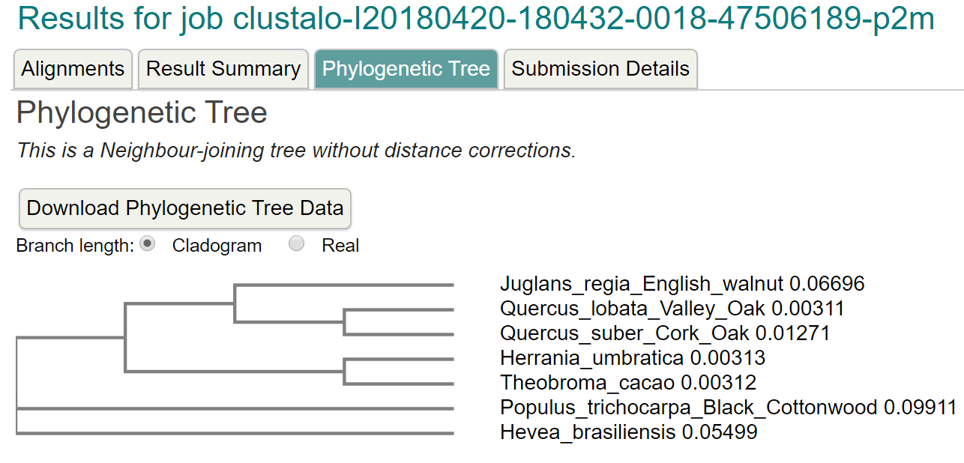

*************************************************************************************

VPVWYNMVNQGLLKEPVFSFWFNRNADEEEGGEIVFGGVDPNHYKGEHTYVPVTQKGYWQFDMGDVMIDG

QTTGFCASGCSAIADSGTSLLVGPTTIITELNHAIGASGIVSQECKTVVAEYGETIIERILAKDQPAKIC

SQIGLCSFDGTHGVSIGIKSVVENTHKVSGDLSDATCSACEMTVVWMQNQLKQNQTQERILDYVNQLCDR

LPSPMGESAVDCAGLSSMPNVSFTIGGRTFDLTPEQYVLKVGEGDAAQCISGFTALDVPPPRGPLWILGD

VFMGRYHTVFDYGNERIGFAEAA

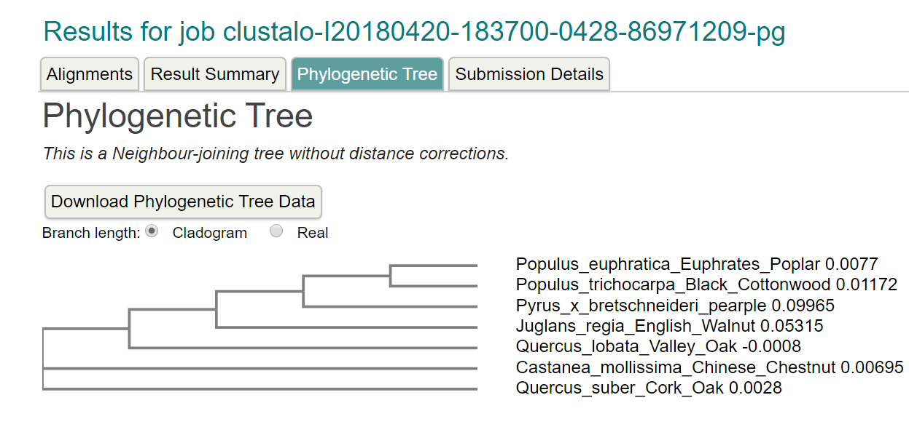

chr8:49455282..49459612 (4.33 Kb): ANNOTATE SEQUENCES WITH YOUR NAME ATTACHED TO IT  
FROM NOW ON

SORRY, all the above WAS NOT

YOUR REGION!

Sorry, all the above WAS NOT EVEN YOUR REGION!

Actual region: chr8h-00004

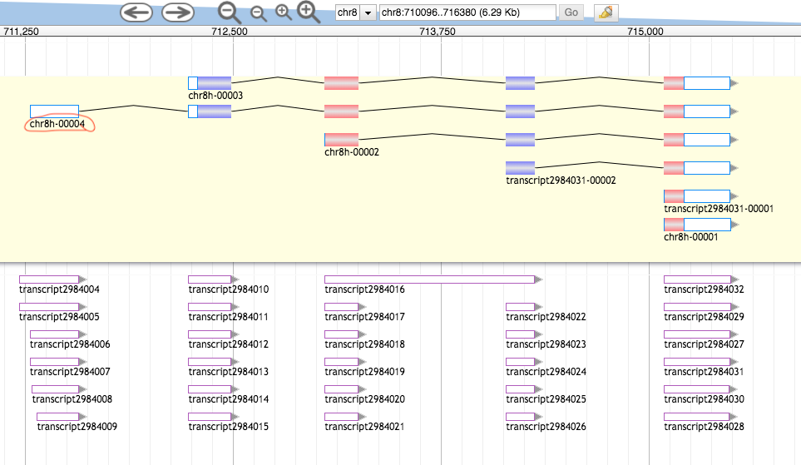



chr8:706211..718780 (12.57 Kb)

Get Peptide Sequence:

>8221e23d-7354-4588-b279-b93bc84e6ad3 (sequence:mRNA) 230 residues [chr8:711279-715487 + strand] [peptide]

MGNKVGKSESPKKVSKPETKLEAKTVEAMKRRAAAGTSMKSFNSIILKFPKIDESLRNCKVIFKQFDEDS

NGAIDYEELKKSFHKLEISCTEEEINDLFQACDINEDKGIDFNEFIVLLCLVYLLKDDAATLHAKARVGM

PDLEATFETLVDAFVFLDKNKDGYVSKSEMVQAINETTSGEGSGQIAMKRFEEMDWDKNGMVNFKEFLFA

FTGWVGIDDNEDEEEGGEK

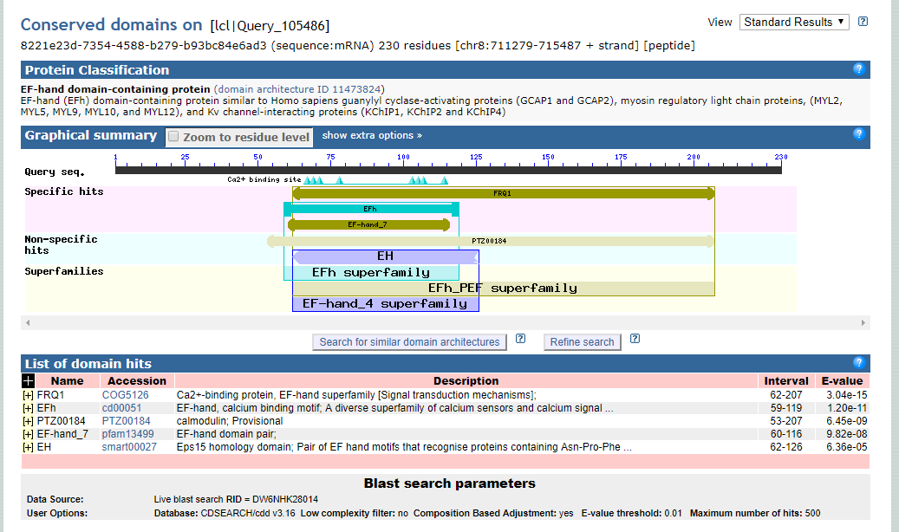

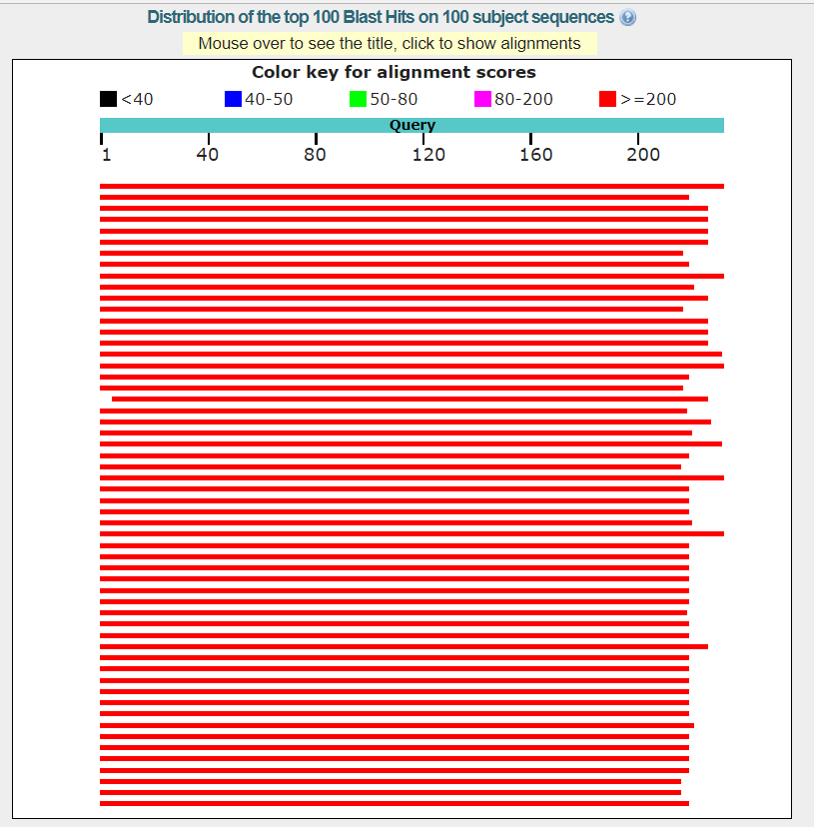

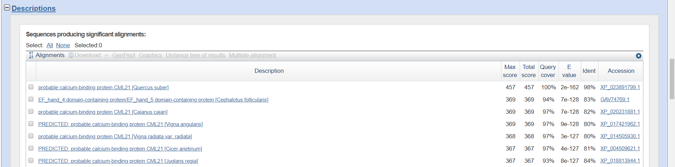

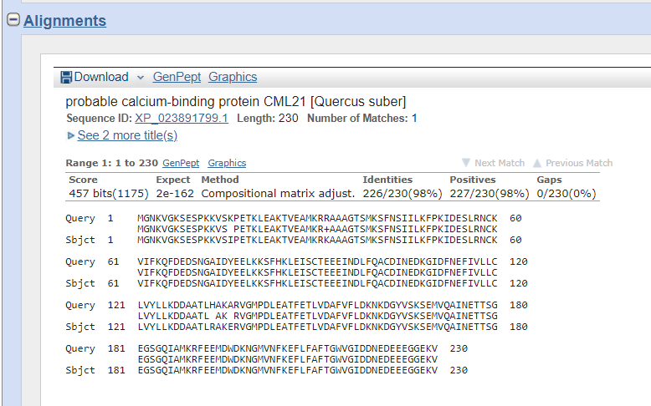

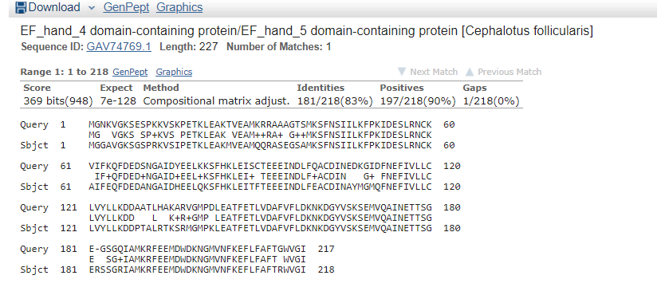

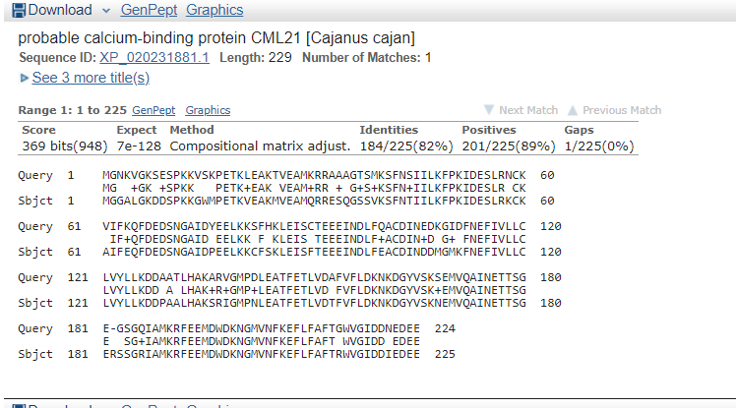

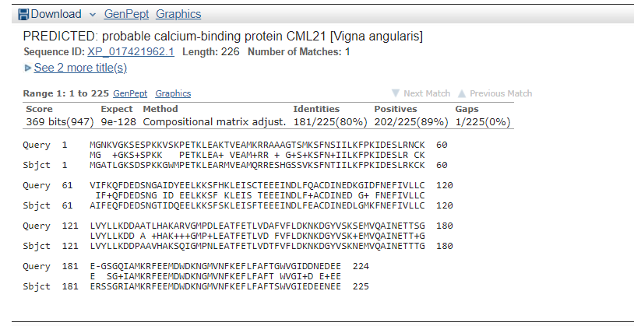

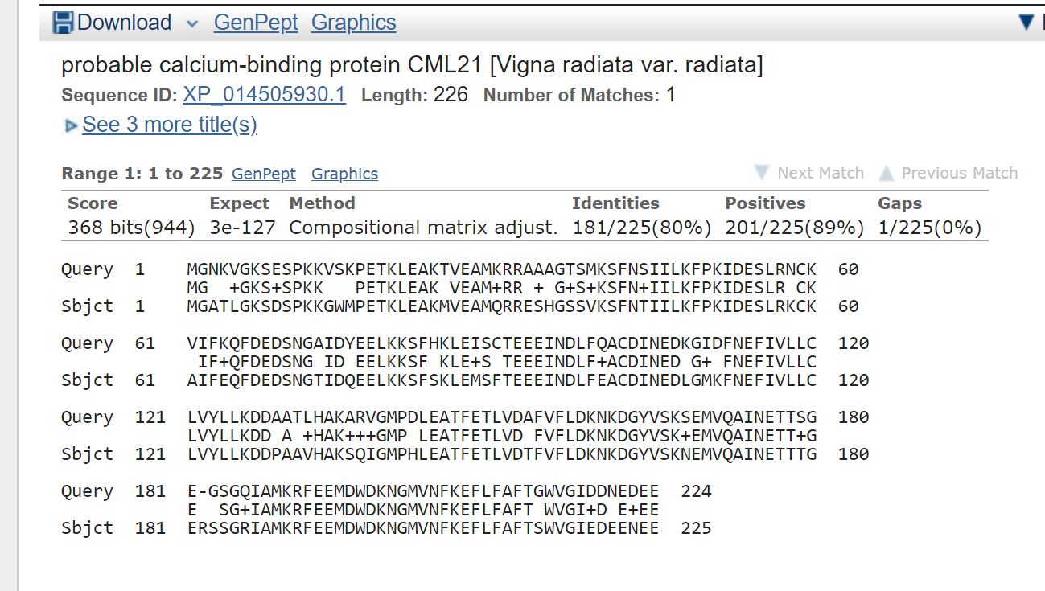

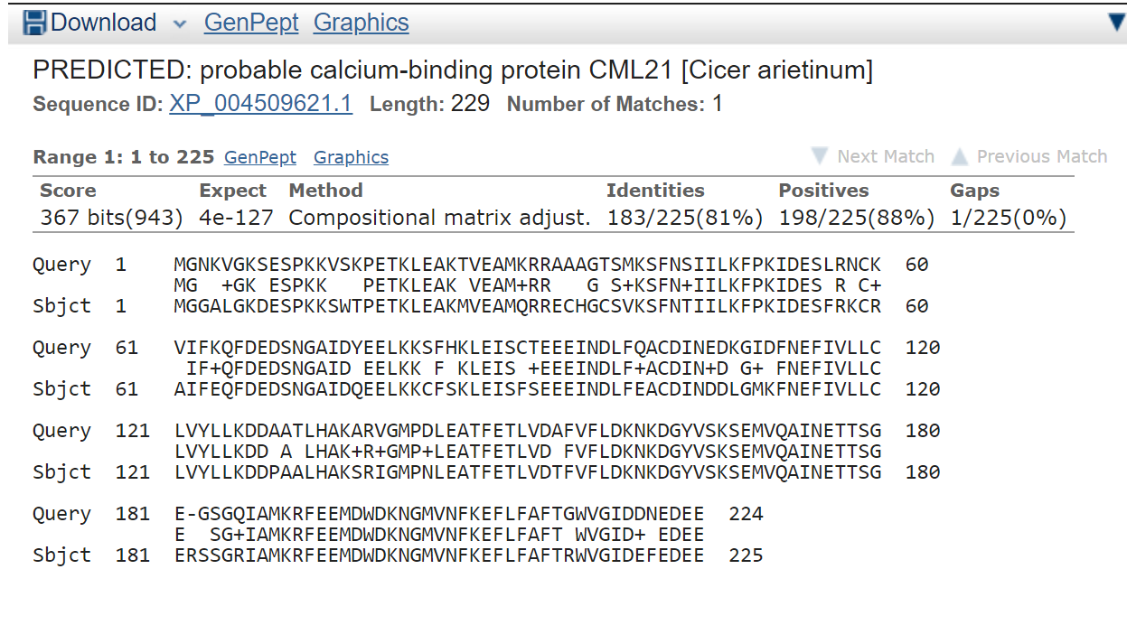

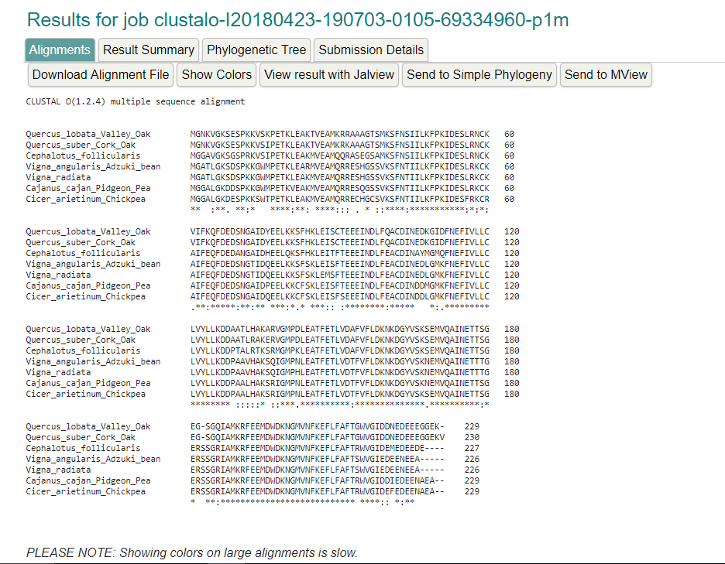

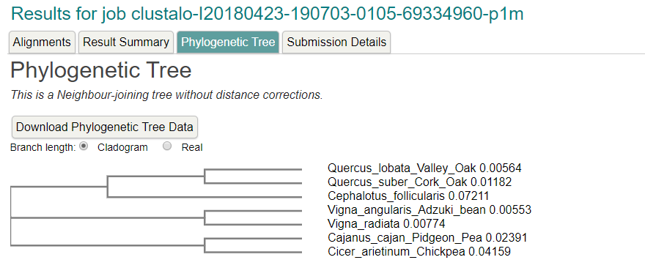

Region: chr8:716586..722870 (6.29 Kb)

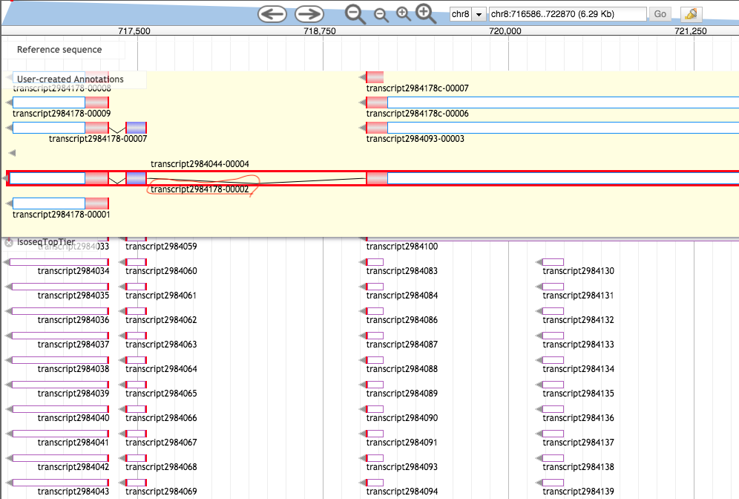

>888593c6-445a-441e-82b5-76e04a4253b9 (sequence:mRNA) 142 residues [chr8:716629-724195 - strand] [peptide]

MLIFIQYNFVGRLLGPRGNSLKRVEASTECRVLIRGRGSIKDPTREEMMRGKPGYEHLNEPLHILVEAEL

PVEIIDARLMQAREILEDLLKPVDETHDFYKKQQLRELAMINGTLREEGSPMSGSVSPFHNSLGMKRAKT

RG

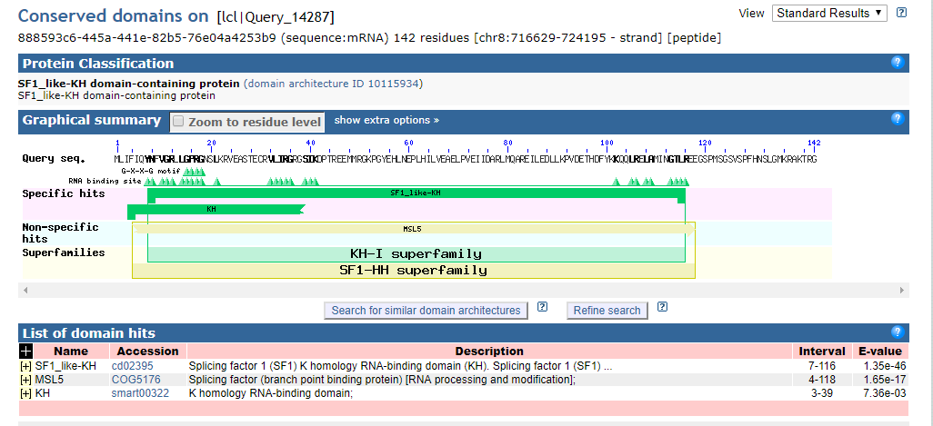

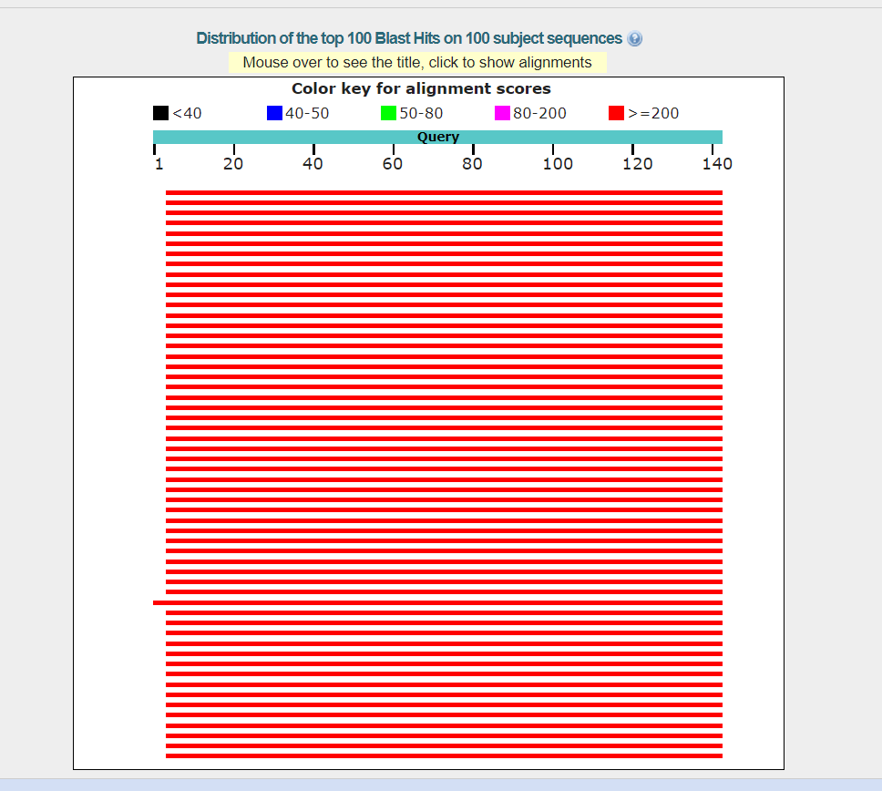

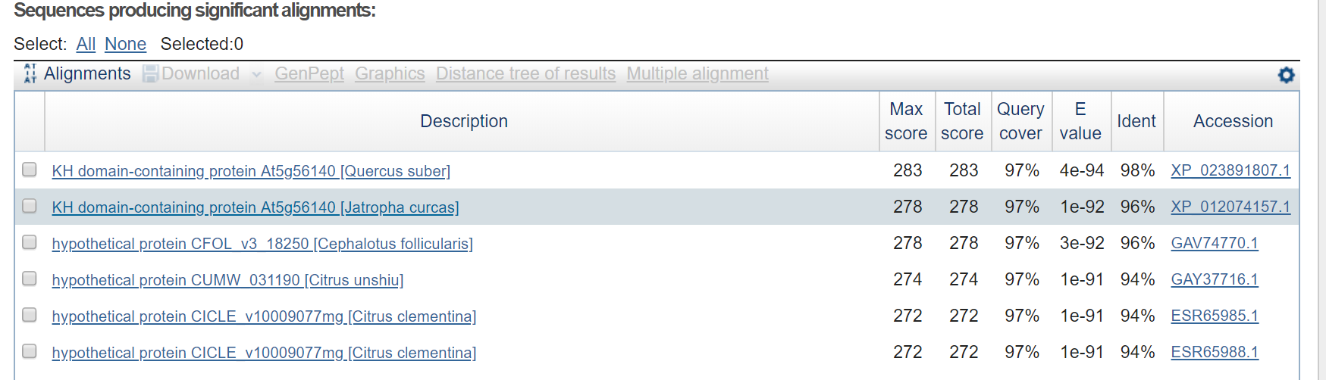

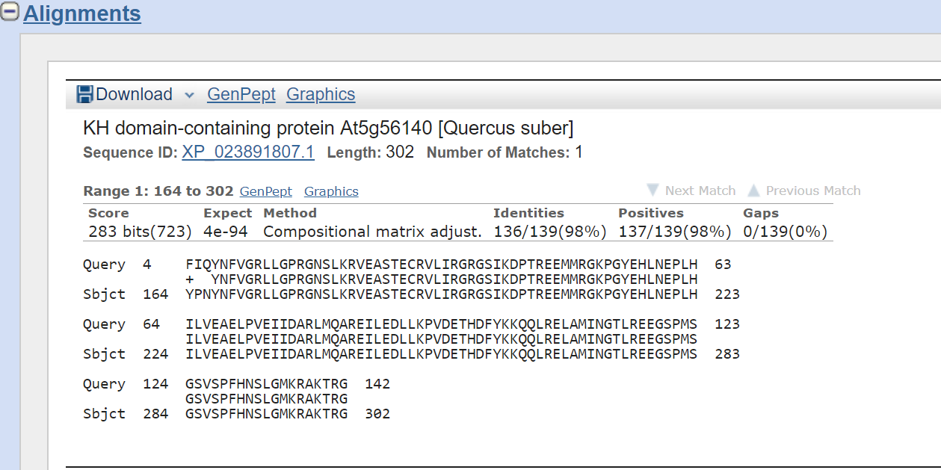

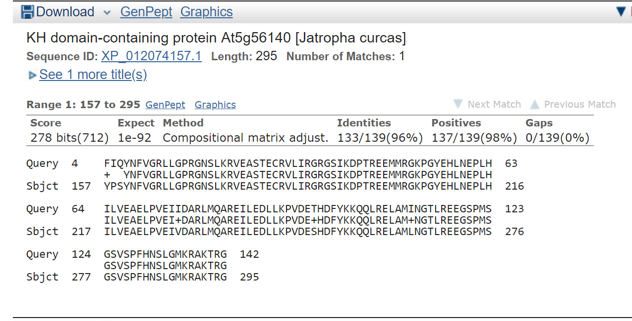

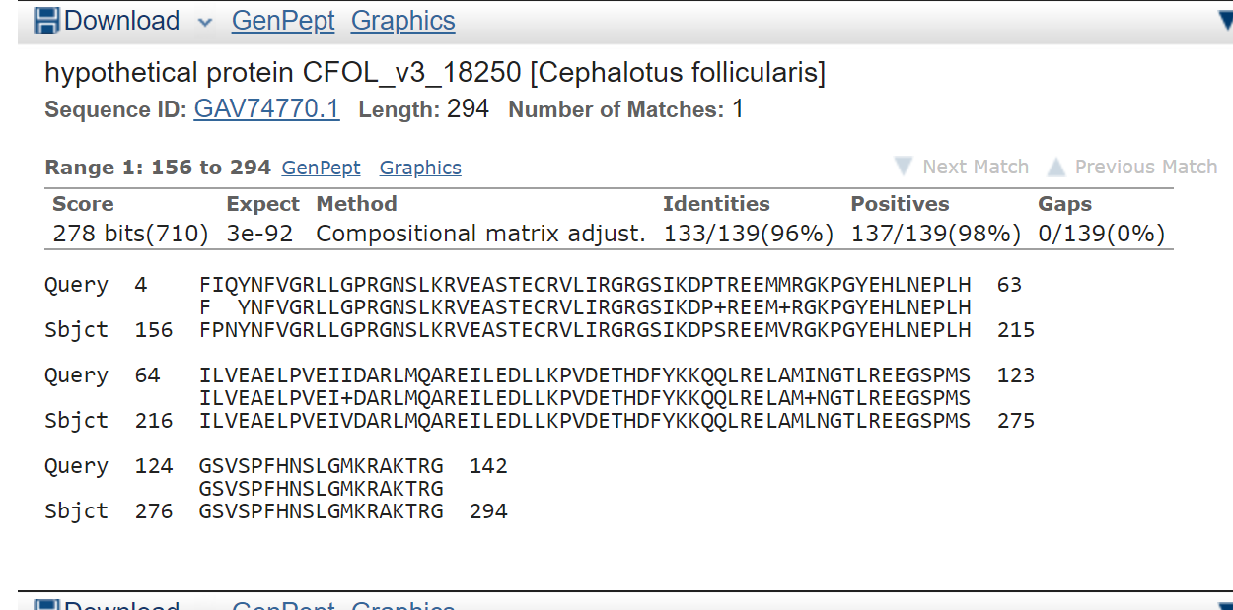

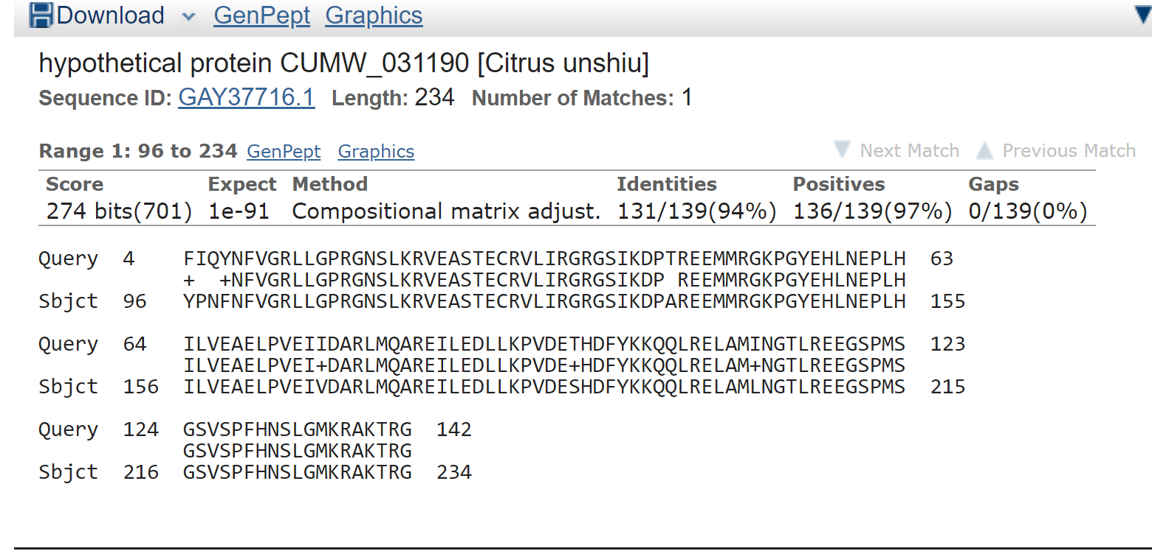

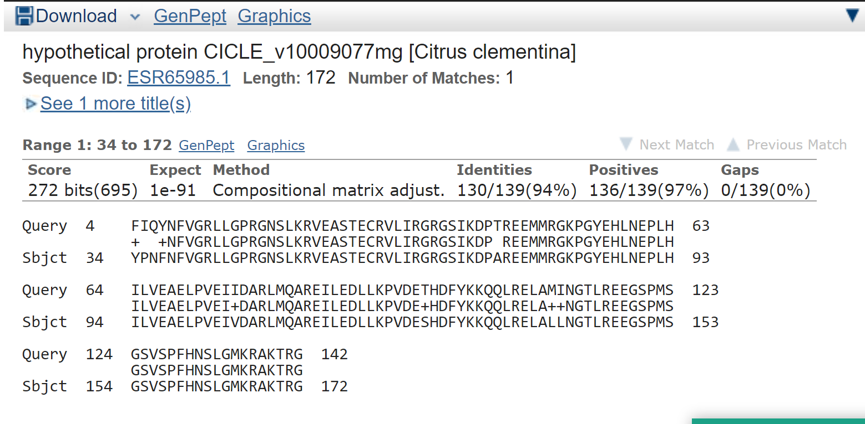

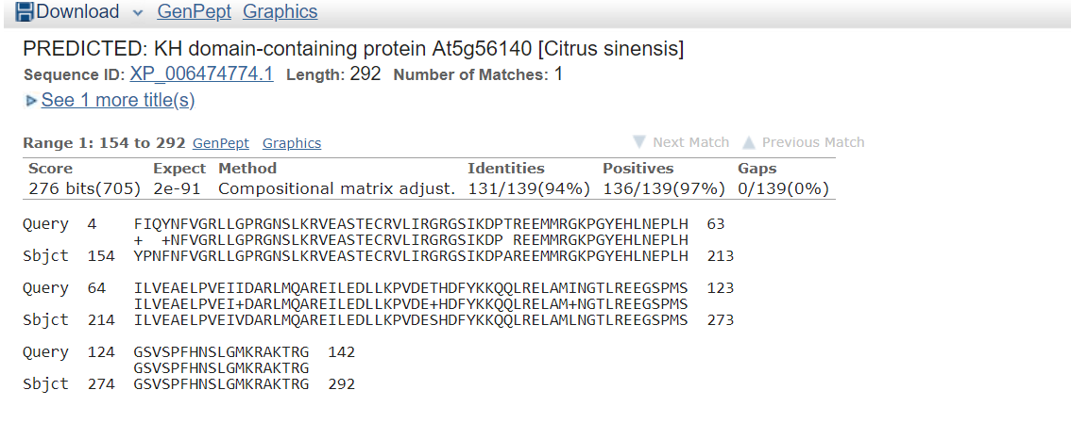

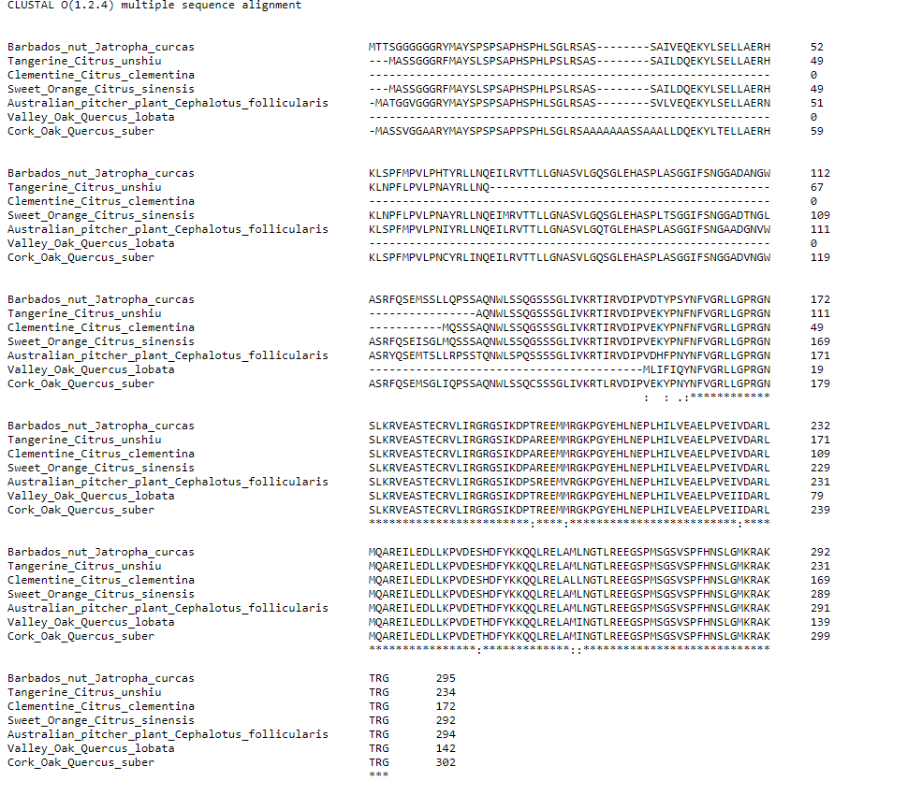

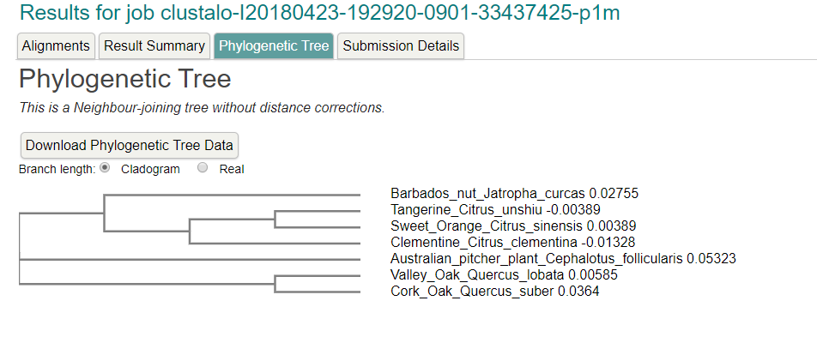

Region: chr8:730346..736630 (6.29 Kb)

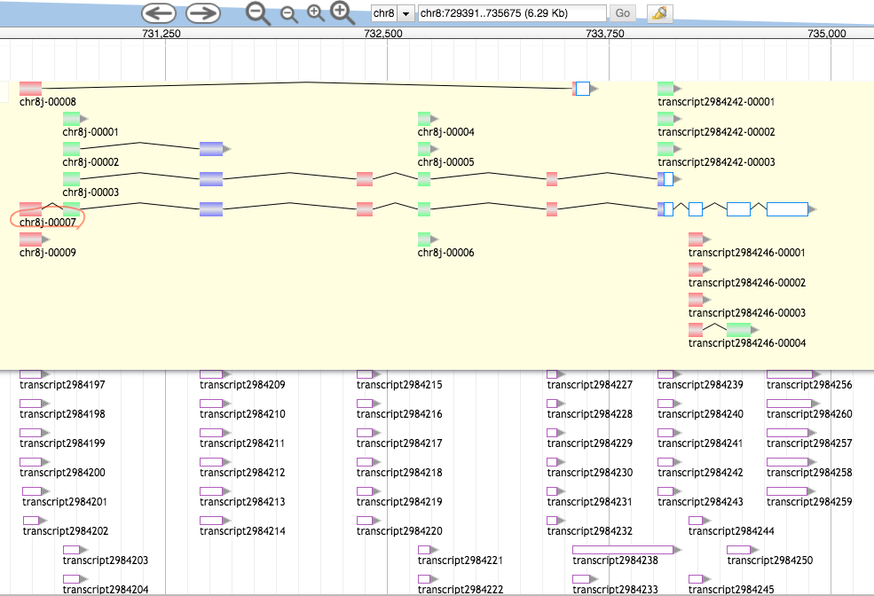

>7ed3267c-1f29-49ec-a967-0a36bab69f8b (sequence:mRNA) 199 residues [chr8:730430-734875 + strand] [peptide]

VSVSEEEVAQEKEKEKEMEGTSTTVPFKNLHSREYQGHKKKVHSVAWNCTGTKLASGSVDQTARLWHIEP

HGHGKVKDIELKGHTDSVDQLCWDPKHGDLIATASGDKTVRLWDARSGKCSMQTELSGENINITYKPDGT

HIAVGNRDDELTILDVRKFKPMHKRKFSYEVNEIAWNMTGEMFFLTTGNDILLLEVLIP

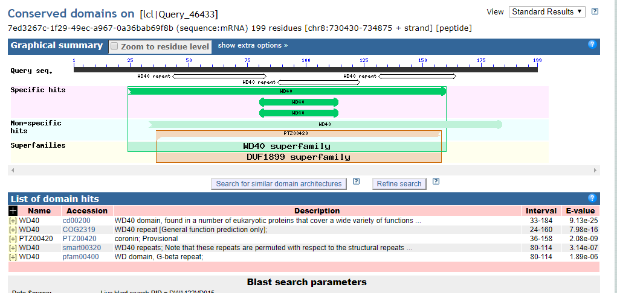

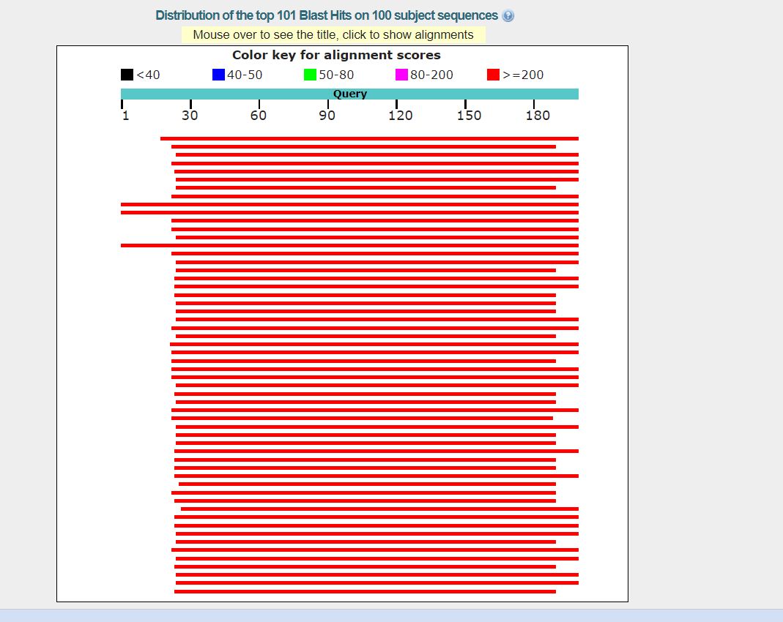

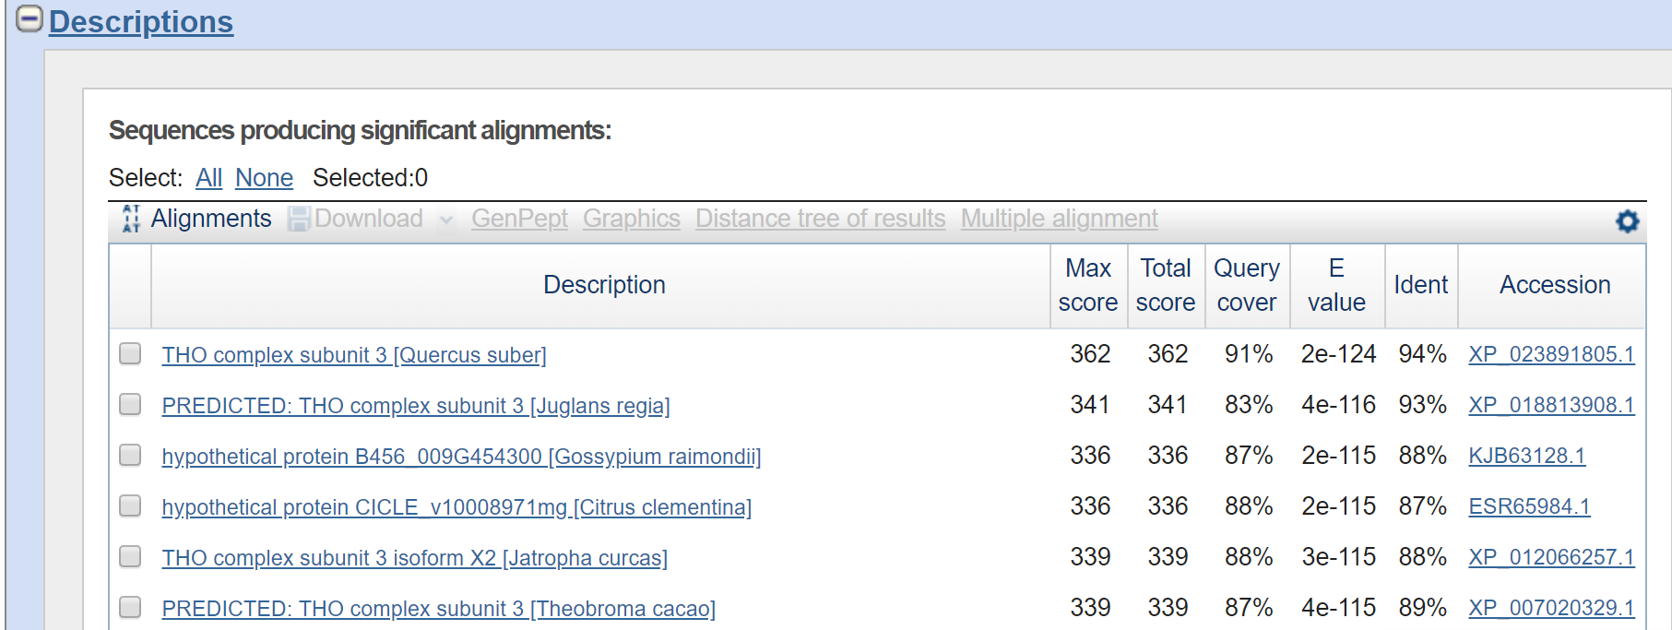

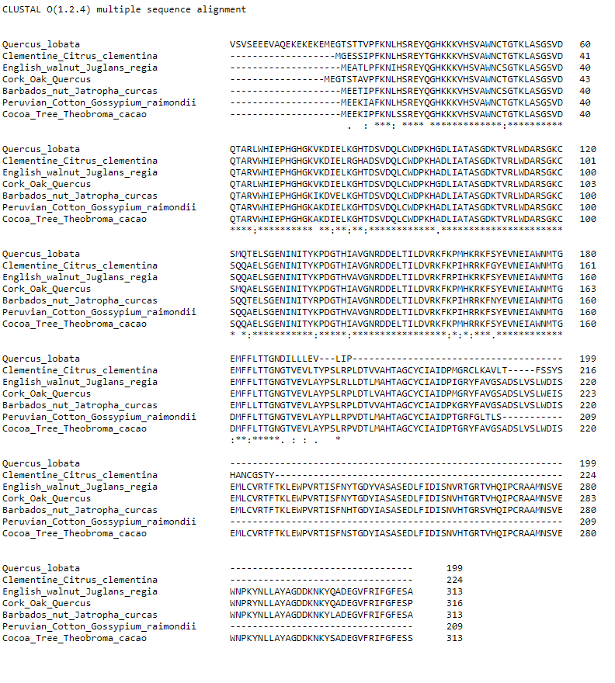

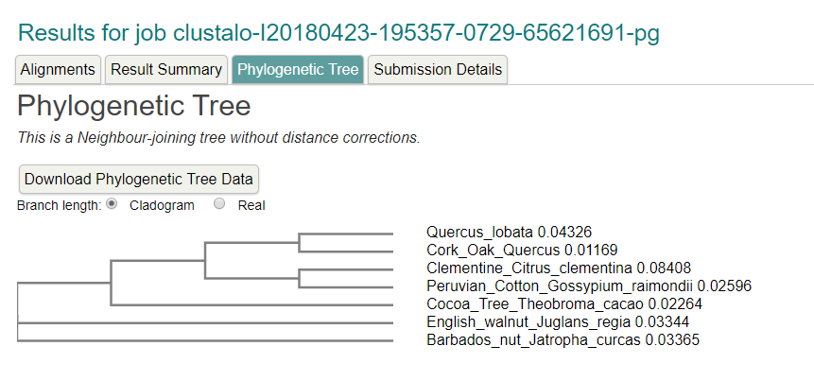

Region: chr8:750116..756400 (6.29 Kb)

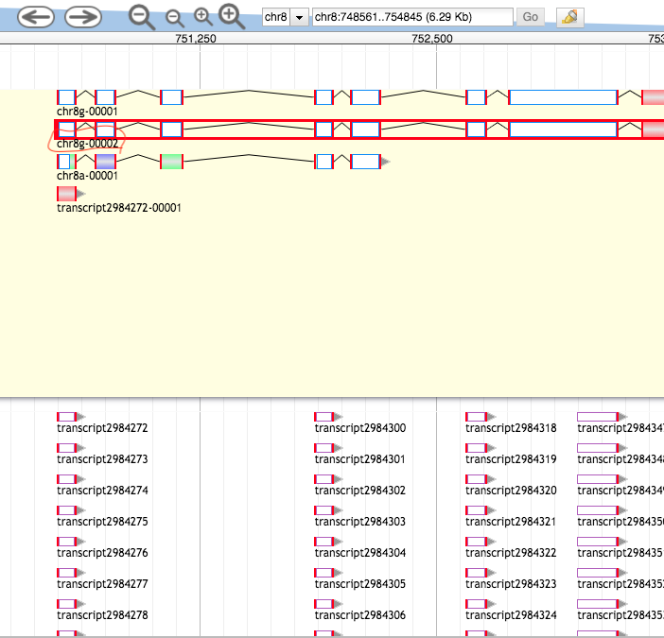

>749cc0cf-94ce-46e8-ad7b-691878547166 (sequence:mRNA) 644 residues [chr8:750495-761746 + strand] [peptide]

MTATHQLEVAVMSIAYVGRSLLLTSISSSSINSVHLDGGNVFINLLMVSLSNALLGMDANDPPKTLATMQ

LIGSIFSNLASLDDNIDGLLFMRISLSQWLDEFLSRLFSLLLYLEPSSVLNEGLNSPATSGTFLVEYSSY

YYCMLEIMLGRLSKSLYDQALRKISKFVKTNTLPGAIEEVGLLCSACIHSNREEAVIHLIEPLLLSVINS

LEDTPVMGFKEGEISKASISIKAKPTLSPALETTINYRLKVLSIAISYGGPALLRYKDQFKEAITSSFDS

PSWKVNSAGDSLLRSLLKSLTRYYPIDQYKSILSHPDAAALEDWISTKDYTNGEPVMPPKWHIPSDDEVQ

FANELLDLHLQSALDDLYRTCQARIHSGPGDRNEHLKVTLLRIDSSLQGVLSCLPDFNPSSRNGTVEDPD

HAPFLIAGATGSSVGGTELREKATEVIHAACKYLLEEKSDDSILLILVIRIMDALGNHGRCWYDAWSGEA

WNLESAAIKEPSINFIVSSNYKGKRRPRWYLIDKAYLHSMWRALKSSYNKFCARGNFYPSNHVILLIDDL

LKLSLHNYGTVRRLAGKTLLKMIERWPSMISKCVLSLTENLRDSKSSEHVVLGSCAVLASKTVFKHLAMD

PKSFCSFIRGILLR

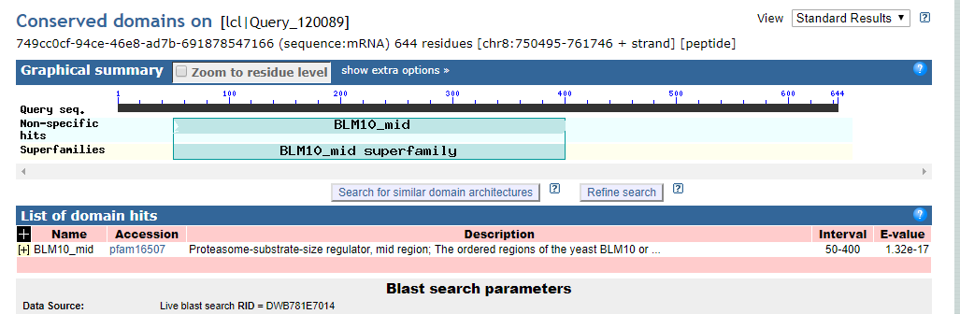

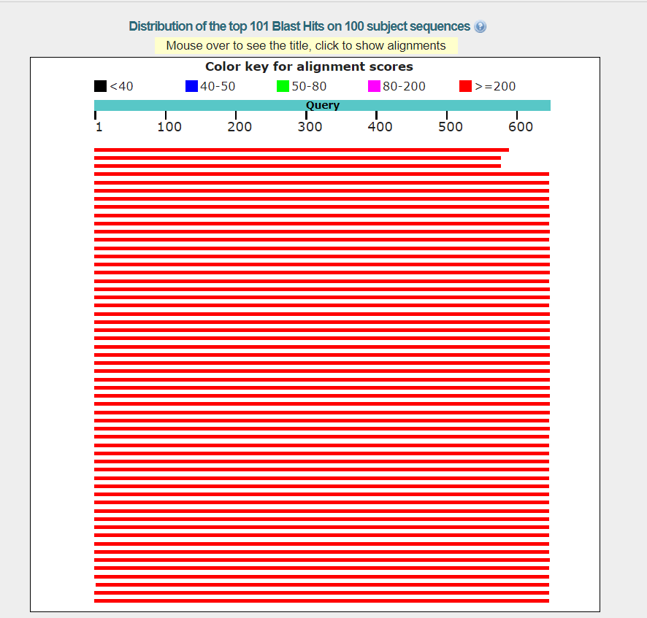

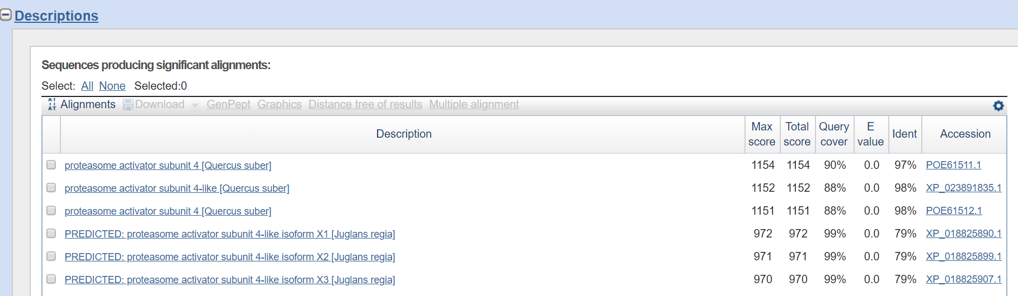

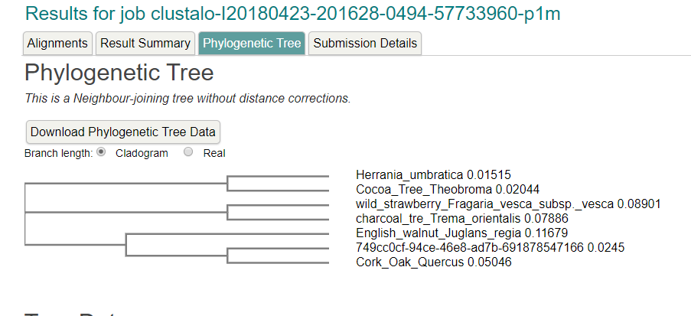

Region: chr8:762831..769115 (6.29 Kb) ERROR: NOTHING FOUND

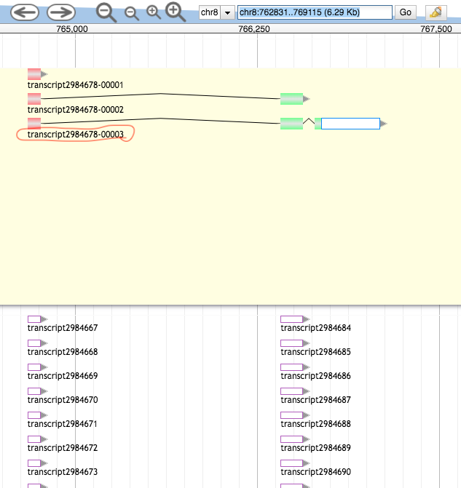

>63a06a12-9680-4118-a40e-2f932fd1fdf2 (sequence:mRNA) 95 residues [chr8:764673-767092 + strand] [peptide]

NMSGGQSVASIHGPVLALTACVLSSPYDMPSWLPEHVILLACFGGEPSPVKSTVTKAVAEFRRTHADTWD

IQKNSFTEEQLEVLADTSSSSSYFA

Region: chr8:774501..780785 (6.29 Kb)

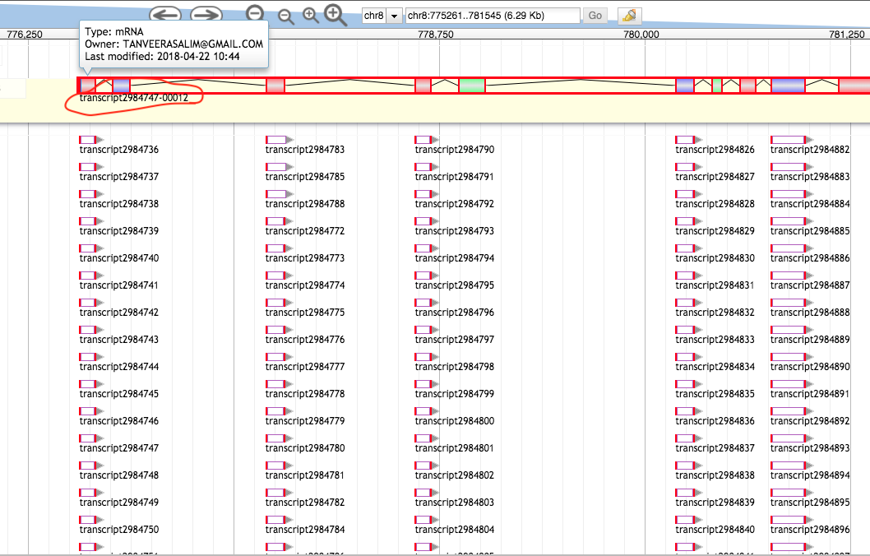

>03743ceb-c990-4b6b-af2b-1d16d080494d (sequence:mRNA) 588 residues [chr8:776562-787077 + strand] [peptide]

FIKAKSDVSLEDVSTLVEIGLELFKNSQNKLYAQVRWGNILVRVLNKYRKKLSLKVQWRPLYDTLVNTHF

TRDTGPEGWRLRQRHFEAITSLVRSCRRFFPPGSAFEIWSEFRSLLENPWHNSSFEGSGFVRLFLPTNLD

NQDFFTNDWIKSCIDLWDSMPNCQFWNSQWAALVARVVKNCNSIEWECFLPTLFARYLNMFEVPVANGSG

SYPFSVDVPRNTRFLFSNKTVTPAKAIAKAIVYLLRPGSLMQDQFEKLVNLLEQYYHPSNGGRWTYSLER

FLFHLVIQFEKRLQHEQQNTENSRQPELLLGRSERTYFVNVVLKLIERGQYSKNEHLSETVAAATSVLSY

VEPSLVLPFVASRFHMALETMTATHQLKIAVMSVAFVGRSLFLTSQSTSVESVESGDEFTDLLMVSLSNV

LLGMDANDPPKTLATMQLIGSIFSNLAYLDDNIDESSFLPMIRFSEWLDEFLCRLFSLLLHLEPSSVMNE

GLHSSATSGTFLVEDGPYYYCMLEILLGRLSKSLYTQAKPTLSPALETSIDYQLKTLSVAISYGGPALLR

YKDQFKEAIVSAFDSPSWKVHLPSPCGF

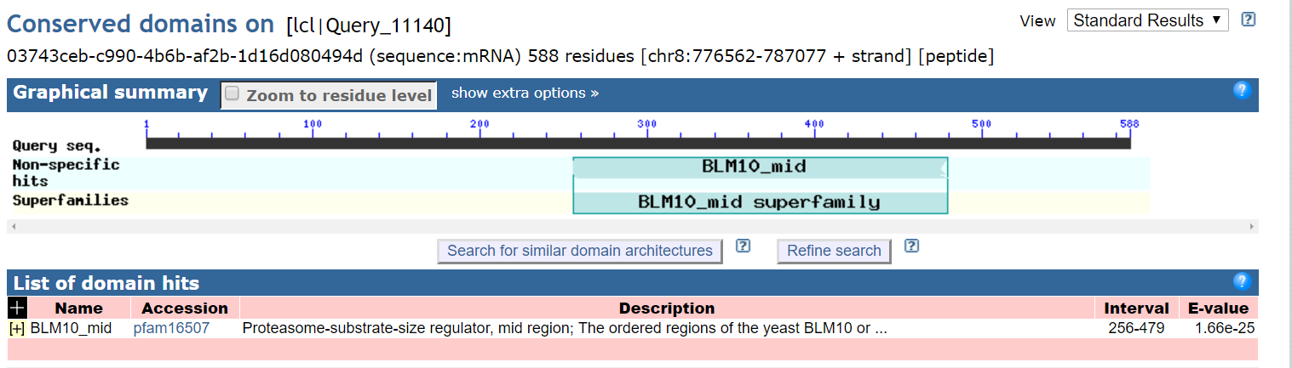

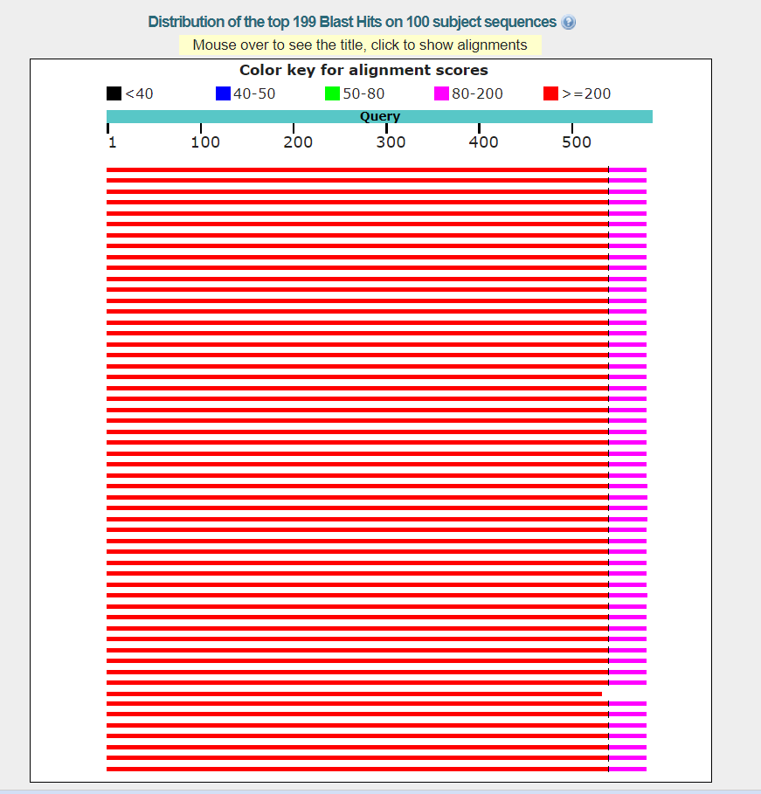

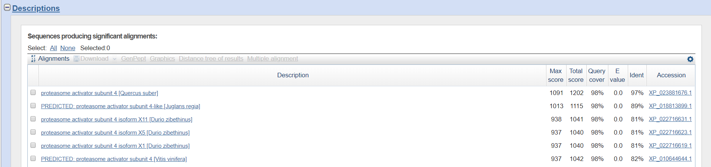

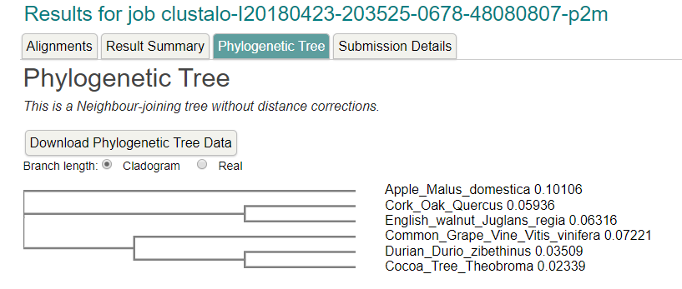

Region: chr8:795344..801574 (6.23 Kb)

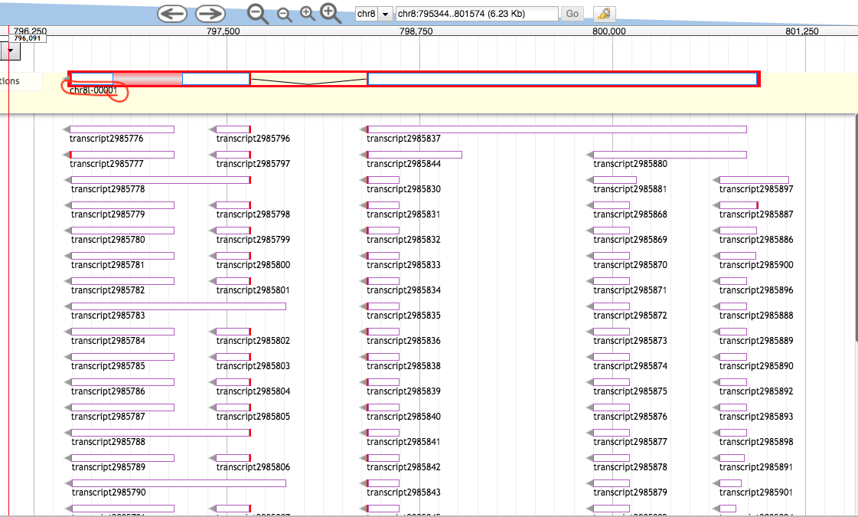

>da72fd12-6192-471d-82ef-9fd3a4cd88a5 (sequence:mRNA) 150 residues [chr8:796485-800948 - strand] [peptide]

MLVYIYLLCFYMCLCWQVYSQPLFANVERWFADKFPSSGFVNDNYTLKLPLLPEIRLNLLRLCFRSIYVV

STTAIAMLFPYFNQVLGVLGGLNFWPLSIYFPVEMYFKQMNIEAWTTKWILLRTFSMFCLLVTLFSLIGS

IEGLITAKLS

